**DAILY ONLINE ACTIVITIES SUMMARY**

|  |  |  |  |  |  |  |  |  |
| --- | --- | --- | --- | --- | --- | --- | --- | --- |
| **Date:** | **14-06-2020** | | | | | **Name:** | **Deril Quadras** | |
| **Sem & Sec** | **8 A** | | | | | **USN:** | **4AL16CS031** | |
| **Online Test Summary** | | | | | | | | |
| **Subject** | | **-** | | | | | | |
| **Max. Marks** | | **-** | | **Score** | | | **-** | |
| **Certification Course Summary** | | | | | | | | |
| **Course** | **CloudEndure Migration Training-Business.** | | | | | | | |
| **Certificate Provider** | | | **AWS** | | **Duration** | | | **40mins** |
| **Coding Challenges** | | | | | | | | |
| **Problem Statement:**   1. **Write a C Program to implement the Binary Reversal**. | | | | | | | | |
| **Status: Solved** | | | | | | | | |
| **Uploaded the report in Github** | | | | | **Yes** | | | |
| **If yes Repository name** | | | | | **Derilquadras/online_c_coding_repository** | | | |
| **Uploaded the report in slack** | | | | | **Yes** | | | |

Online Test Details:

Not Conducted

Certification Course Details:

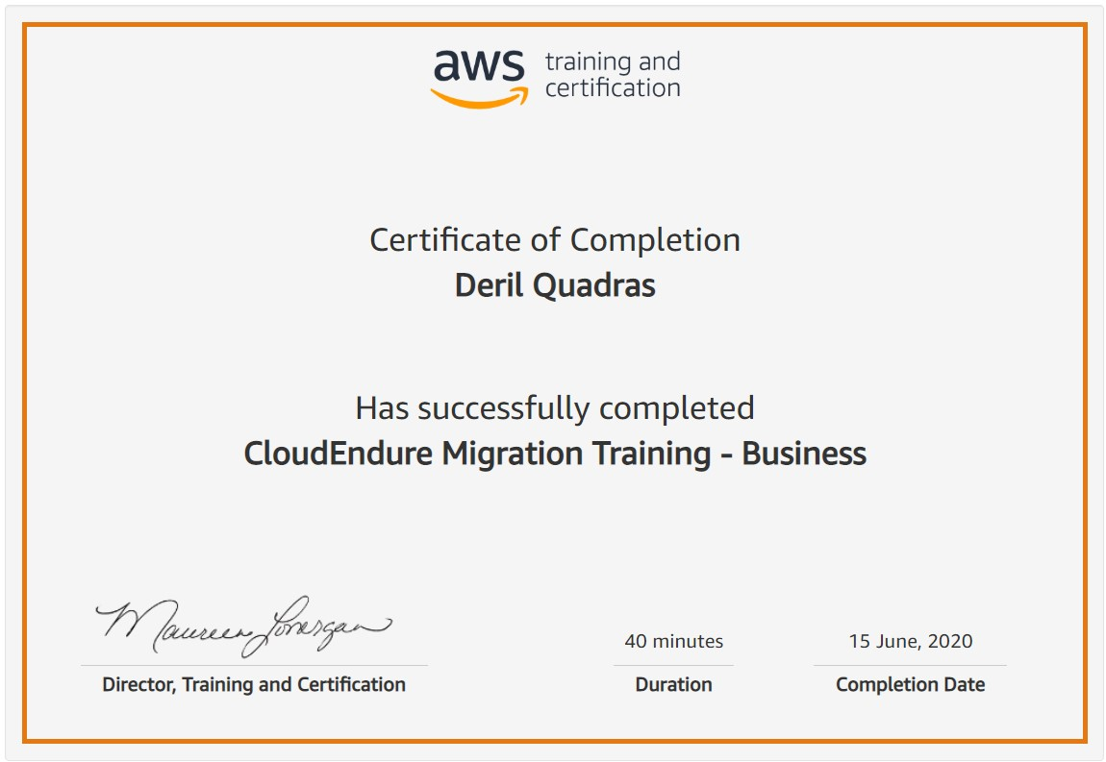

Coding Challenges Details:

**PROGRAM 1 .**

**//Write a C Program to implement the Binary Reversal**

**#include <stdio.h>**

**unsigned int reverseBits(unsigned int n)**

**{**

**unsigned int rev = 0;**

**while (n > 0)**

**{**

**rev <<= 1;**

**if (n & 1 == 1)**

**rev ^= 1;**

**n >>= 1;**

**}**

**return rev;**

**}**

**int main()**

**{**

**unsigned int n = 213;**

**printf("%d",reverseBits(n));**

**return 0;**

**}**